Name : Dhwani patel

College: Silver Oak University

Python Django task 1

Day 7

Views.py

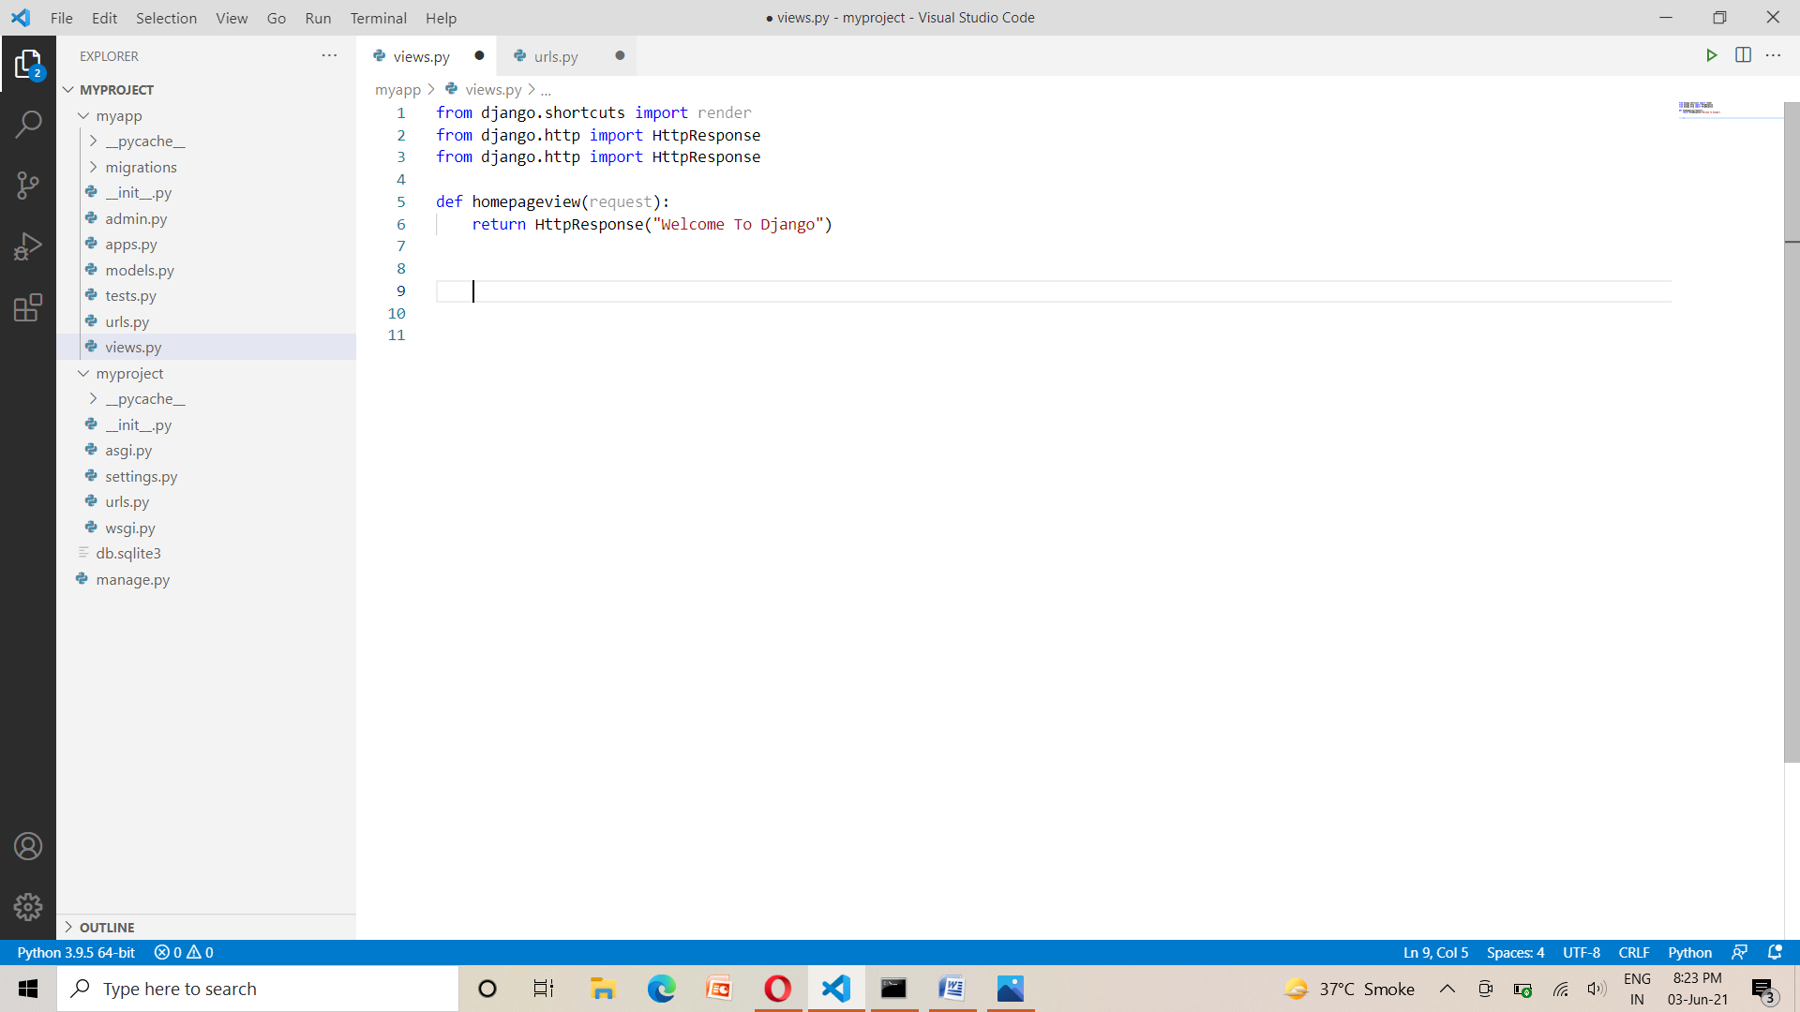

Urls.py

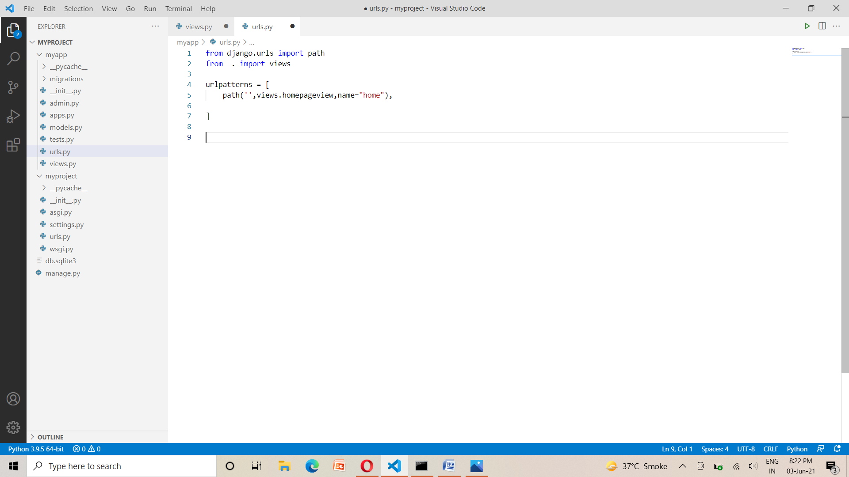

Output

